

# EXERCISE: USER DEFINED CLASS

**STIA1123 –PROGRAMMING II**

**Task 1**

// The Triangle class stores and manipulates data for a //triangle.  
   
public class Triangle  
{  
 private double height;  
 private double base;  
  
 // The setHeight method accepts an argument which is

//stored in the height field.  
  
 public void setHeight(double len)  
 {  
 height = len;  
 }  
  
 // The setBase method accepts an argument which is

//stored in the base field.

public void setBase(double b)  
 {  
 base = b;  
 }  
  
 //The set method accepts two arguments which are

//stored in the height and base fields.

public void set(double len, double b)  
 {  
 height = len;  
 base = b;  
 }  
  
 // The getHeight method returns the value stored in the

// height field.  
  
 public double getHeight()  
 {  
 return height;  
 }  
  
 // The getBase method returns the value stored in the

//base field  
  
 public double getBase()  
 {  
 return base;  
 }  
  
 // The getArea method returns the value of area

// with formula : 0.5 * height * base  
  
 public double getArea()  
 {  
 return 0.5 * height * base;  
 }  
}

Type the above definition of a Triangle class and save in a file.

1. What is the name to be given to this file?

Triangle.java

1. Compile this file. If you get any error, it means that you haven’t typed correctly the given codes.
2. After a successful compilation, now try to run. Explain what happened and why.

The program cannot be run because it has no main method.

**Task 2**

import _____________________________________

public class TriangleDemo  
{  
 public static void main(String[] args)  
 {

//create a Scanner object

_______________________________________________  
  
 // Create a Triangle object.  
 _______________________________________________  
  
 // Prompt user to input value for height and base

_______________________________________________

_______________________________________________

_______________________________________________

_______________________________________________

//Set the height and base (use mutator)   
 _____________________________

____________________________  
 // Display the height, base and area (use accessor)  
 System.out.println("The pyramid's height is "  
 + ______________________);  
 System.out.println("The pyramid's base is "  
 + ______________________);  
   
 System.out.println("The pyramid's area is "  
 + ______________________);  
   
 }  
}

Complete the above Java program and save it **in the same folder** where the Triangle class file is located.

1. Compile this file. If you get any error, it means that you haven’t typed correctly the given codes.
2. After a successful compilation, now try to run. What’s the output?

1 import java.util.Scanner;  
 2 public class TriangleDemo  
 3 {  
 4 public static void main(String[] args)  
 5 {  
 6 //create a Scanner object  
 7 Scanner scan = new Scanner (System.in);  
 8   
 9 // Create a Triangle object.  
10 Triangle tri = new Triangle();  
11   
12 // Prompt user to input value for height and base   
13 System.out.print ("Enter the triangle's height : ");  
14 double height = scan.nextDouble();  
15 System.out.print ("Enter the triangle's base : ");  
16 double base = scan.nextDouble();  
17   
18 //Set the height and base (use mutator)   
19 tri.set(height,base);  
20   
21 // Display the height, base and area (use accessor)  
22 System.out.println("The pyramid's height is " + tri.getHeight());  
23   
24 System.out.println("The pyramid's base is " + tri.getBase());  
25   
26 System.out.println("The pyramid's area is " + tri.getArea());   
27 }

28   
29 public class Triangle  
30 {  
31 private double height;  
32 private double base;  
33   
34 // The setHeight method accepts an argument which is   
35 //stored in the height field.  
36   
37 public void setHeight(double len)  
38 {  
39 height = len;  
40 }  
41   
42 // The setBase method accepts an argument which is   
43 //stored in the base field.   
44   
45 public void setBase(double b)  
46 {  
47 base = b;  
48 }  
49   
50 //The set method accepts two arguments which are   
51 //stored in the height and base fields.  
52   
53 public void set(double len, double b)  
54 {  
55 height = len;  
56 base = b;  
57 }  
58   
59 // The getHeight method returns the value stored in the   
60 // height field.  
61   
62 public double getHeight()  
63 {  
64 return height;  
65 }  
66   
67 // The getBase method returns the value stored in the   
68 //base field  
69   
70 public double getBase()  
71 {  
72 return base;  
73 }  
74   
75 // The getArea method returns the value of area  
76 // with formula : 0.5 * height * base  
77   
78 public double getArea()  
79 {  
80 return 0.5 * height * base;  
81 }  
82   
83 }  
84 }

OUTPUT :

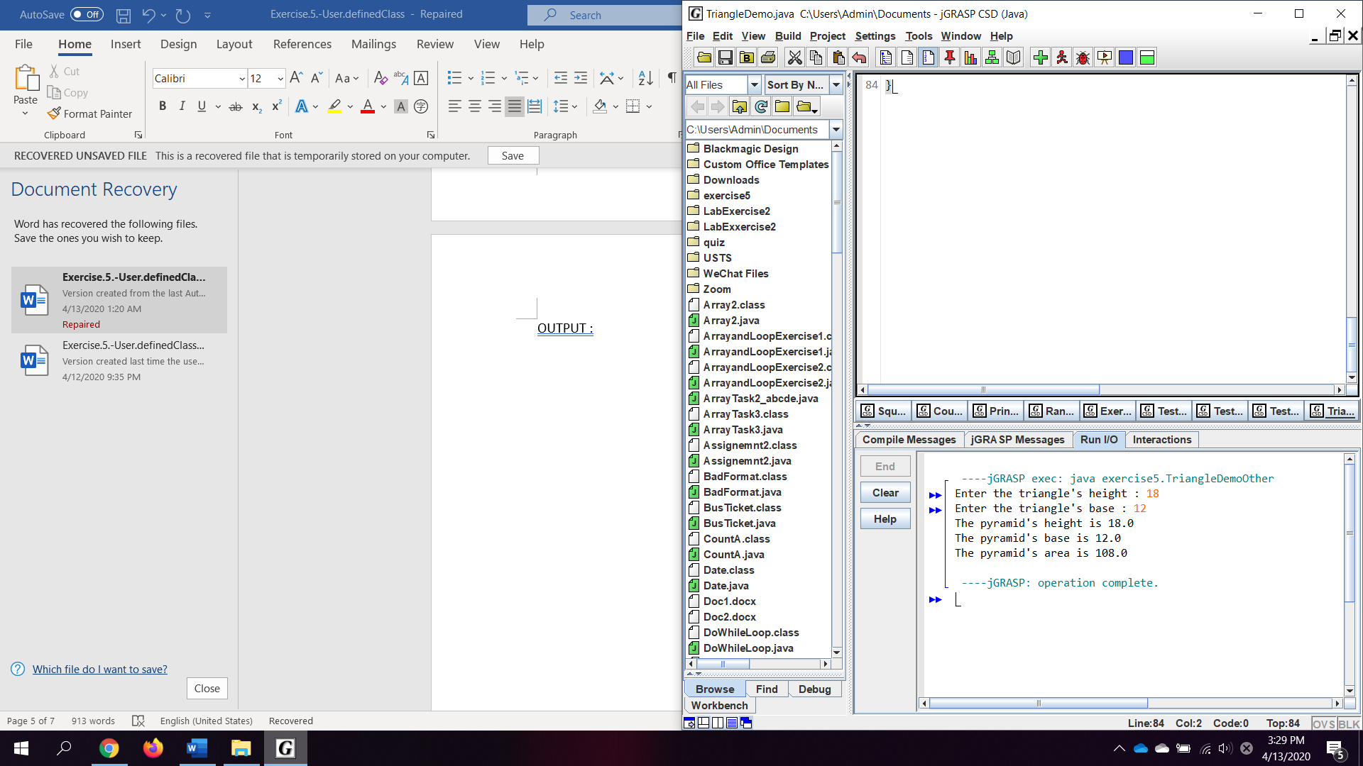

1. List **ALL** the following items based on the Triangle class:
2. object : Triangle
3. user-defined methods with return value :

getHeight();

getBase();

getArea();

1. user-defined methods with passing-parameters :

setHeight(double len)

setBase(double b)

set(double len, double b)

1. accessor methods :

getHeight()

getBase()

getArea()

1. mutator methods :

setHeight(double len)

setBase(double b)

set(double len, double b)

**Task 3**

Develop an Employee class which consists of employee ID number, gross pay, state tax and federal tax. You also must create input () method to prompt a user to insert employee ID number, gross pay, state tax and federal tax.

Next, develop a Payroll class that consists of two user-defined methods, namely calculateNetPay() and printOutput() methods. The calculateNetPay() method is used to calculate the employee’s net pay, as follows:

|  |
| --- |
| **Net pay = gross pay – state tax - federal tax** |

In the same class, print the net pay value in the printOutput() method.

Then, develop a PayrollDemo class which consists of the main method. Inside the main method, create **TWO (2)** objects to invoke input(), calculateNetPay() and printOutput() methods.

Your program should produce the following output:

Enter your employee ID number: 2150  
Enter your Gross Pay :RM 4000  
Enter your State Tax :RM 300  
Enter your Federal Tax :RM 500  
  
Net pay is : RM 3200.00

*Note: The underlined values are entered by the user.*

Code :

1 import java.util.Scanner;  
 2 public class PayrollDemo  
 3 {  
 4 public static void main (String [] args)  
 5 {  
 6   
 7 Employee emp = new Employee();  
 8 emp.input();  
 9 Payroll payr = new Payroll(emp.grosspay, emp.statetax, emp.federaltax);  
10 payr.calculateNetPay();  
11 payr.printOutput();  
12 }  
13 }  
14   
15 class Employee  
16 {  
17 double id, grosspay, statetax, federaltax;  
18 public void input()  
19 {  
20 Scanner scan = new Scanner (System.in);  
21   
22 System.out.print("Enter your employee ID : ");  
23 id = scan.nextDouble();  
24 System.out.print("Enter your gross pay : RM ");  
25 grosspay = scan.nextDouble();  
26 System.out.print("Enter your state tax : RM ");  
27 statetax = scan.nextDouble();  
28 System.out.print("Enter your federal tax : RM ");  
29 federaltax = scan.nextDouble();  
30 }  
31 }  
32   
33 class Payroll  
34 {  
35 private double grosspay, statetax, federaltax, netpay;  
36   
37 public Payroll (double grosspay, double statetax, double federaltax)  
38 {  
39 this.grosspay = grosspay;  
40 this.statetax = statetax;  
41 this.federaltax = federaltax;  
42 }  
43   
44 public double calculateNetPay()  
45 {  
46 netpay = grosspay - statetax - federaltax;  
47 return netpay;  
48 }  
49   
50 public void printOutput()  
51 {  
52 System.out.printf ("%nYour net pay is : RM %.2f " , calculateNetPay());  
53 }  
54 }

Output :

